CKAPP01 -

Functionality
The report displays the following materials:
- Materials that can be costed (the No Costing indicator is not set in the costing view of the material master)
- Materials for which no marked or released standard cost estimates exist in the system
This report can be used to check if materials that do not have cost estimate (marked or released).

Scenario
Run this report to check if there are any semi-finished products ‘HALB’ or finished products to be costed in plant 1200.

Requirements
The Materials Master data were created with Costing Views.

Menu Path | Accounting → Controlling → Product Cost Controlling → Product Cost Planning → Material Costing → CKAPP01 – Display Materials to be Costed
Transaction Code | CKAPP01

1. Double click on CKAPP01 – Display Materials to be Costed.

Display of materials to be costed

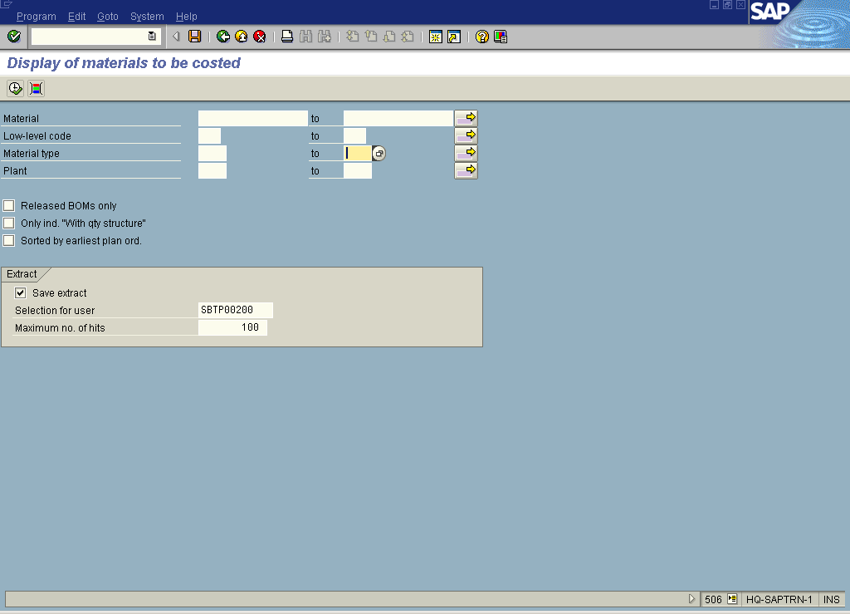

2. Click the Material Type multiple selection button.

Multiple Selection for Material Type

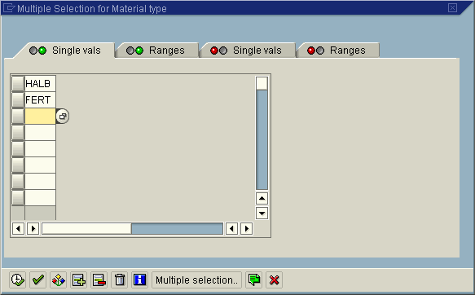

3. Update the following fields:

Field Name | Field Description | Values
Material Type | Code identifying the material type | Example: HALB
Material Type | Code identifying the material type | Example: FERT

4. Click the Copy button.

Display of materials to be costed

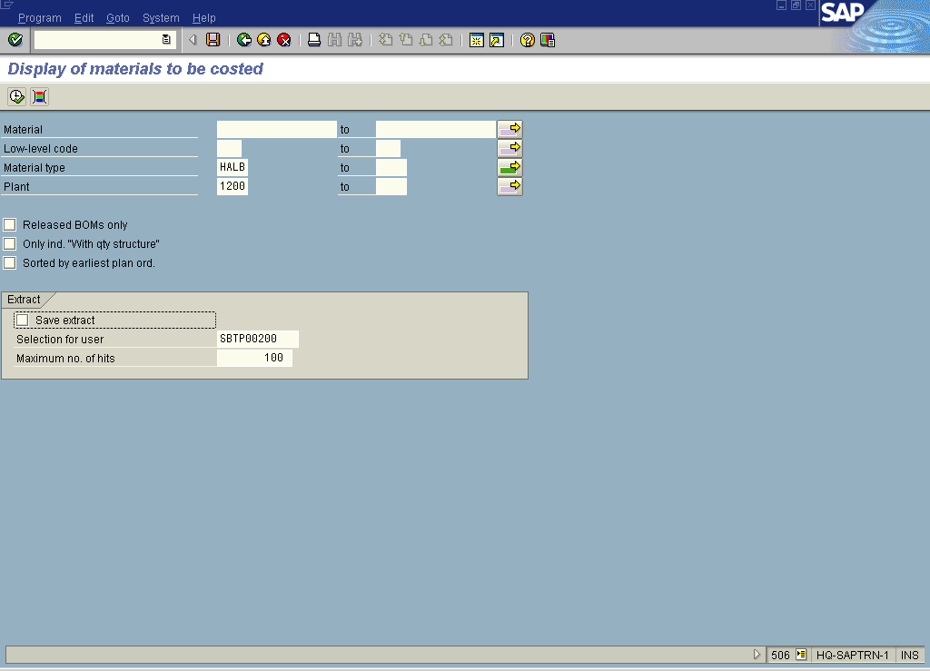

5. Update the following fields:

Field Name | Field Description | Values
Plant | Code identifying the operational unit of the company where the material is manufactured and stored | Example: 1200

6. Click the Save extract checkbox to deselect.

7. Click the Execute button.

Display of materials to be costed

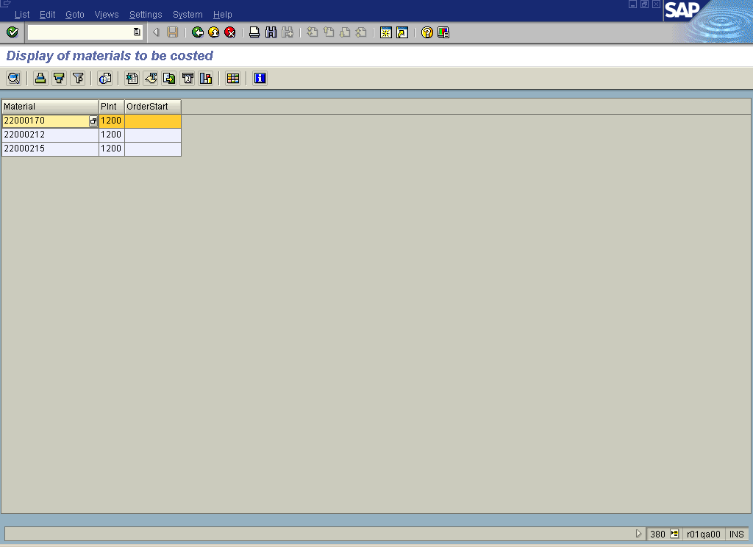

8. Click the Back button.

Display of materials to be costed

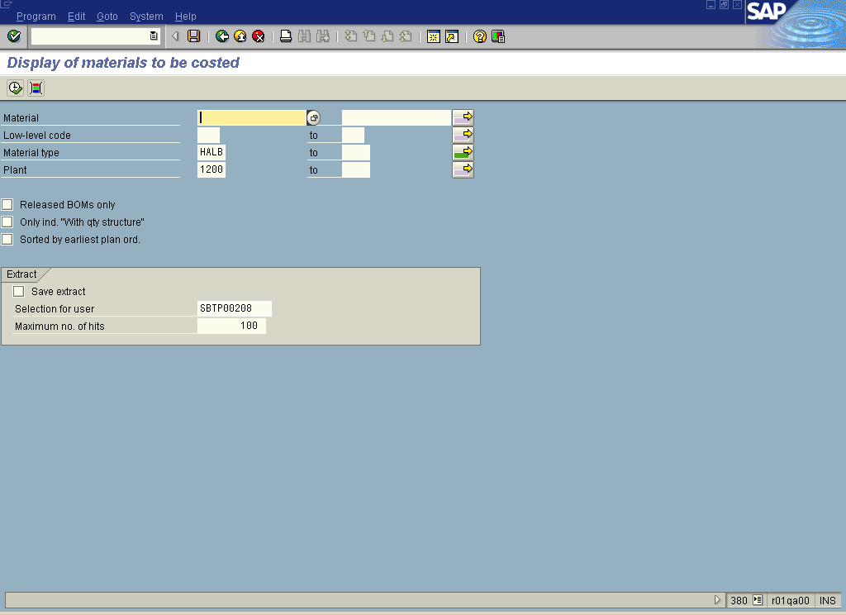

9. Click the Back button to go back to SAP Easy Access screen.

